**TASK REPORT**

**BUSINESS**



**By:**

**Tasya Amanda Adinegara**

**-**

**Data Science Student**

**Data Fellowship**

**2020**

**Chapter 1**

**Introduction**

Doing Data Science without a sense of business is like playing chess without the kings on the board. For every business, making its products or services better is the ultimate goal of a data science project. Leaving that out of the picture is nonsensical. Your data team could feature the best coders and the best statisticians, but if they don’t know the actual business application of their data projects, the whole thing will be pointless.

On a high level, you can achieve two things with data science.

**#1 Understanding your audience better.** Learning about their needs, their struggles, their motivations, their habits and their relationships to your product or service.

**#2 Using this understanding to create a better product or service and turning that into profit.**

Your number one priority should be to help your users. As a consequence of that, your product or service will flourish. And that better product or service will bring you more users, more returning users and eventually more revenue.

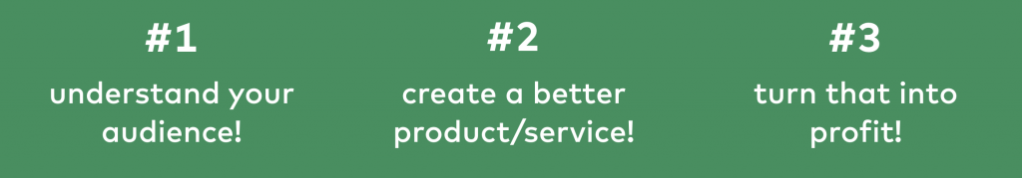

Study Case :McJager Consulting (MJC) consultant proposed a data science project to Telcozee. Telcozee is a communication service provider. The purpose of the proposal is to predict customer churn. Telcozee wants to characterize customers who will sleep so they can try to get involved them with some incentives. It took 90 days for observation. For the record, the problem itself does not include the customer which reconnects long after the contract ends. What is meant by churn is a customer still inactive 45 days before the contract expires. MJC proposes random forest modeling with an accuracy of 80%. This model will do it recommend top N customers who have the most probability to churn. This paper tries to find deficiencies and suggests some improvements about it. Also this the paper attempted to write a related proposal.

**Chapter 2**

**Progress Report**

In this chapter you will have to fill in the table below according to the progress of the project that you have made along the way. We need to know how long it takes for you and how big the effort that you have done in order to complete this task. We appreciate detailed information.

|  |  |  |  |
| --- | --- | --- | --- |
| **Day/Date** | **Task** | **Level** (easy/medium/hard) | **Comments** |
| 15/05/2020 | Reading and exploring the data | Easy | I can undestand the article. |
| 15/05/2020 | Doing Analysis | Medium | It’s not really hard to do analysis |
|  |  |  |  |
|  |  |  |  |

**Chapter 3**

**Task Report**

1. 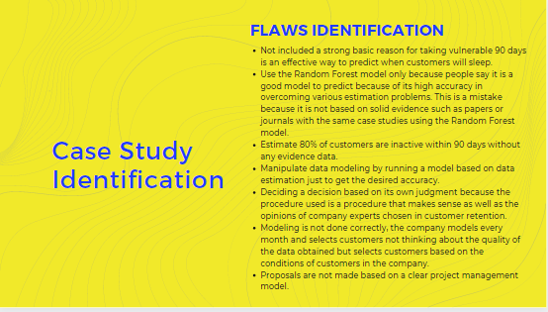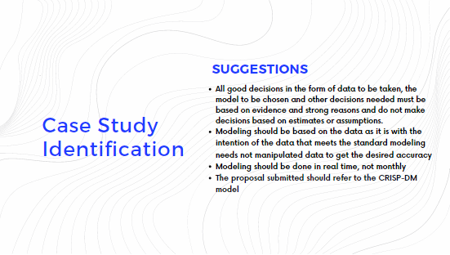Do you find any flaws with the plan? Do you have any suggestions for how to improve it? If yes, list them all (minimum 5 flaws and 5 improvements)
2. Based on your understanding, flaws identification and improvement suggestions above, create a proposal document in a pdf format, that contains summary background, technical approach, datasets, experiment and evaluations, software and hardware used, and milestones.

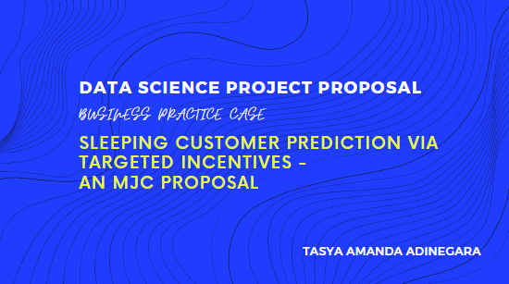***Attached***

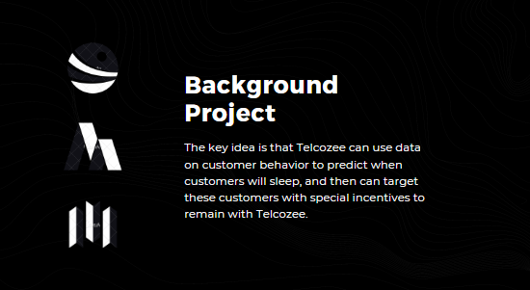

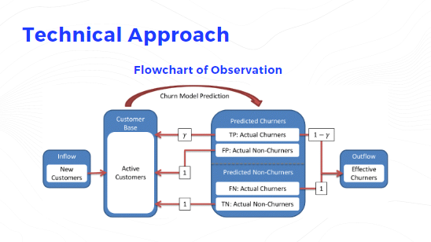

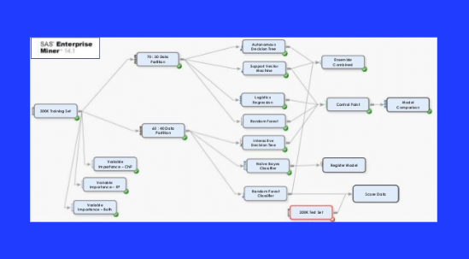

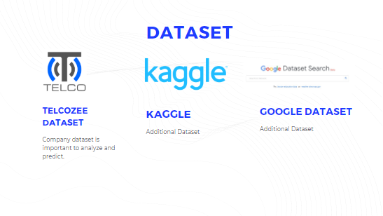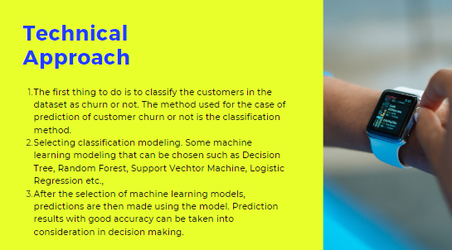

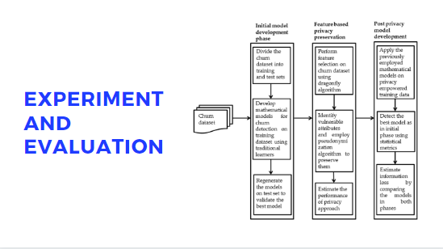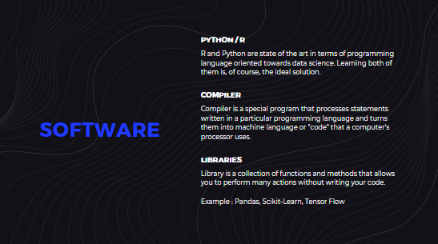

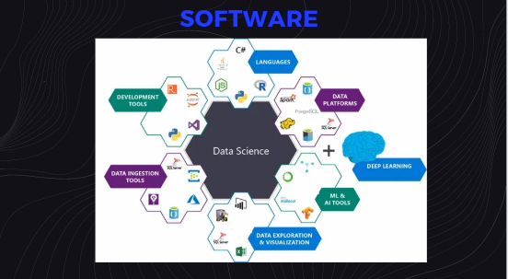

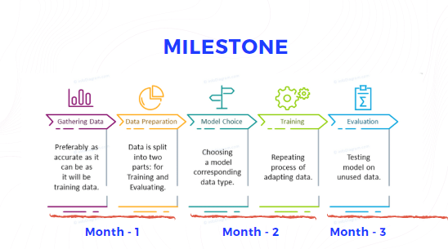

Conclusions :

In writing a proposal every content of the proposal must be based on facts or evidence of the truth of the argument to be conveyed. In making the model, try to be made one by one and write a good proposal in this case using the CRISP-DM method.